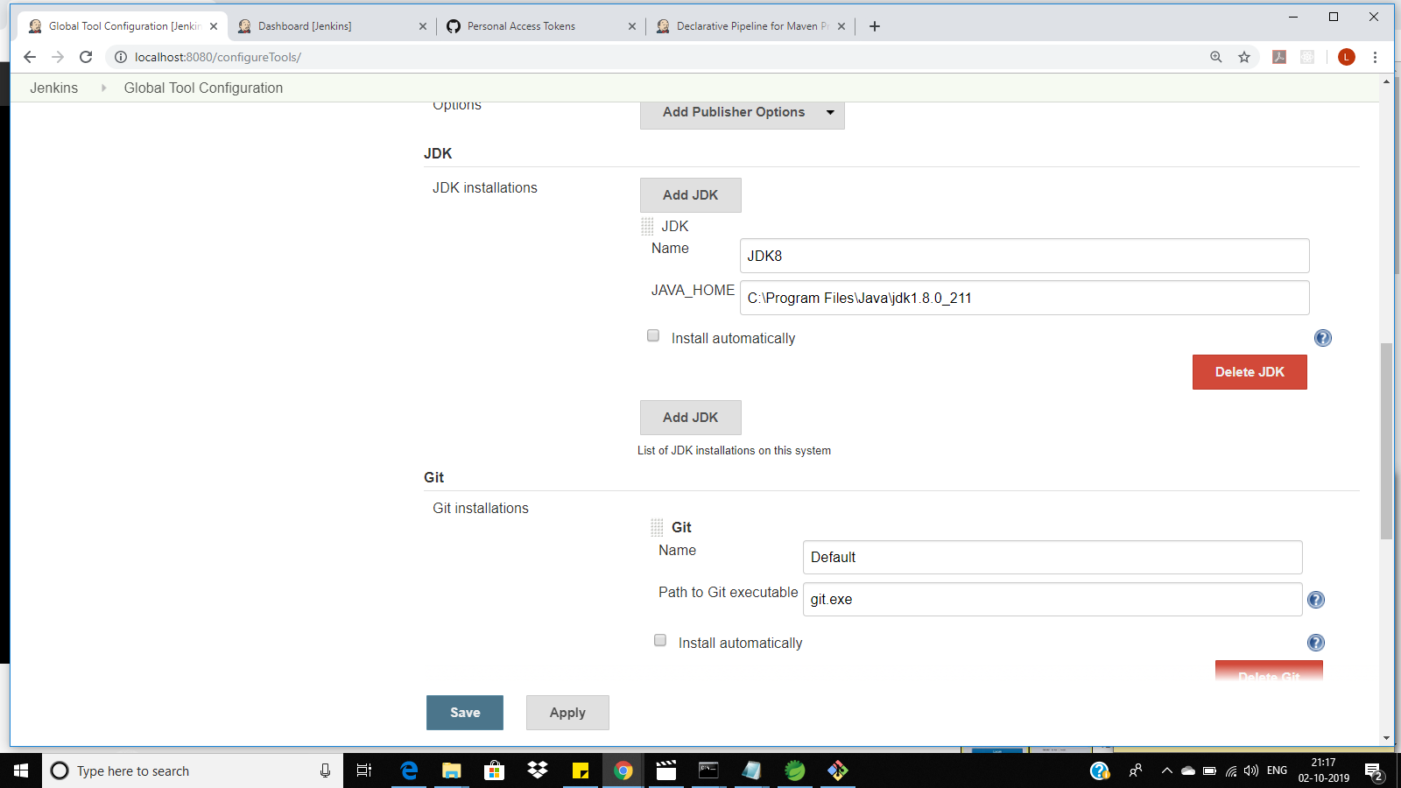

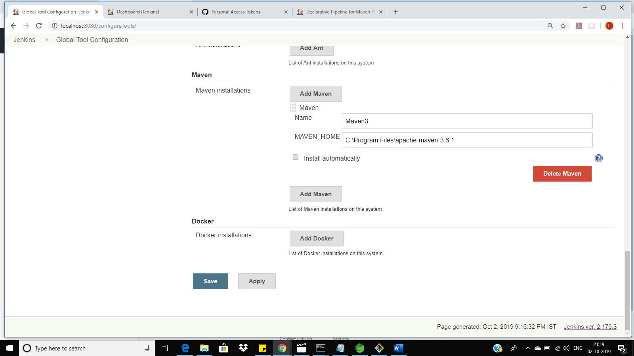

Pipeline syntax

Simple java application which will check out from github and build and run

Screen shot of build

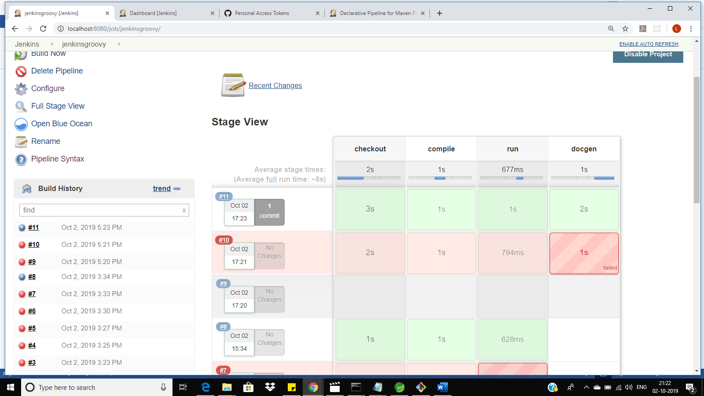

node {

stage ("checkout")

{

git url:"https://github.com/lsubrama24/GroovyJenkinsDemo.git"

}

stage ("compile")

{

// def JAVAHOME = "C:\\"Program Files"\\Java\\jdk1.8.0_211"

bat "javac Hello.java"

echo "done"

}

stage ("run")

{

bat "java Hello"

echo "done"

}

stage("docgen")

{

bat "javadoc Hello.java"

}

}

**Pipeline script for checking out from GITHUB and running a maven build**

**Pipeline Script**

pipeline {

agent any

tools {

maven 'Maven3'

jdk 'JDK8'

}

stages {

stage("checkout")

{

steps {

git url:"https://github.com/lsubrama24/MAVEN-JENKINS-DEMO.git"

}

}

stage("Maven Build")

{

steps {

bat "mvn install -f JenkinsDemo"

echo "done"

}

}

stage("run")

{

steps {

bat "java -jar JenkinsDemo\\target\\JenkinsDemo-0.0.1-SNAPSHOT.jar"

echo "done"

}

}

stage("deploy"){

steps {

bat "copy JenkinsDemo\\target\\JenkinsDemo-0.0.1-SNAPSHOT.jar E:\\GRROVYDEPLOY"

}

}

}

}

Screen shot

